|  |
| --- |
| **Confidential**  **Revenue Recognition – Conflict handling from manual change and Worklist for Contracts with Conflicts**  **Changed on 03.04.2017** |

| **Users who have change authorization in the Working Version** | |
| --- | --- |
| Xin Fang | I042117 |
| *A list of all users and their roles can be found in the Appendix | |

**Table of Contents**

1 Software Requirements, Use Cases, ..

2 Appendix (generated)

# Software Requirements, Use Cases,

## Business Context and Scope

## Business Context

In RAR, end user can manually change the following Revenue Contract in 4 different ways:

* Attributes of the performance obligation
* Price allocation
* Revenue spreading
* POB structure

Once a manual change has happened, later if sender component sends update to RAR, this leads to conflict in RAR on the contract, and in RAR there will be 3 kinds of conflicts

* **Conflict on Manual changed Attributes:**

Attribute on the Operation document is changed again

* **Conflict on Manual changed Attributes:**

A time-based POB of which the spreading changed manually has a new allocated amount

* **Conflict on Revenue Schedule:**

**Notice:** Currently there is conflict handling on POB structure as it is out of scope. This means the manually changed POB structure will be flushed away.

RAR shall be able to provide the following functionality:

* Ability to detect conflicts
* Review contracts with conflicts in a worklist
* Store previous manual changed value or using previous changed value as a reference to review and correct conflict

## Scope of this SRS

* Store manual POB change on attributes/price allocation/manual spreading
* Flag to indicate different manual change POB
* Conflicts on POB attributes
  + Determine conflicts
  + Resolve conflicts
* Conflicts on manual price allocation
  + Determine conflicts
  + Resolve conflicts
* Conflicts on manual spreading
  + Determine conflicts
  + Resolve Conflicts

## Out of Scope

* Conflicts on manual changed POB structure

If the POB structure is changed manually, and later POB is updated by a new order RAI update, the previous manually changed POB structure will be overwritten.

## Use case

**Use case 1:**

**Manual change on POB attributes**

Revenue Accountant adjust the attribute of a POB manually in Revenue Accounting. For example, adjust the start date and end date of a POB or standalone selling price of a certain performance obligation

Later the attribute (like SSP) is changed from the operation document either by a new value, and the new value is different from the manual changed value on POB, this will cause a conflict on this attribute

**Use case 2:**

**Manual change on Spreading**

Revenue Accountant manually adjusts the spreading of a time-based POB based on the allocated amount of the POB, later due to price change or manual adjustment on allocation, the allocated amount is changed. This causes a conflict on the manual spreading value between the allocation and manual spreading.

**Use case 3**

**Manual change on Price Allocation**

Revenue Accountant manually adjusts the price allocation of a Revenue Contract. Later the transaction price of the contractual price is changed, the system will flush the manual price allocation performed before away.

## Software Specification

## REQ-001: RAR shall indicators on contract and indicate different manual changes on a Revenue Contract

When POB is manually changed, RAR shall set an indicator on Contract and POB to indicator what

In Revenue Accounting, when manual changes are performed, following flag be set.

* **Indicators on Contract: (FARR_D_CONTRACT)**
  + Flag **“Price was allocated manually on the Contract**” on contract: it is true when manual price allocation is performed on Contract.
  + Flag “**Manually changed**” on contract: it is true when any manual change (on attributes/price allocation/spreading) is set.

* **Flags on POB: (FARR_D_POB)**
  + Flag “**Spreading Manually Changed**”: it is set when the spreading of the POB is manually set.
  + Flag **“Manually Changed**”: it is set when the attribute of the POB is manually changed.

In summary, here is a list of what manual change are perform and which flag are marked.

|  |  |  |  |  |
| --- | --- | --- | --- | --- |
| Manual action | Manually changed on Contract | Manual changed on POB | Price was allocated manually on Contract | Spreading manually changed on POB |
| Change attributes | X | X |  |  |
| Change price allocation | X |  | X |  |
| Change spreading | X |  |  | X |

[Open]: Do we need to add consistency check?

[TODO]: update with technical name

## REQ-002: RAR shall persist manual change information in Revenue Accounting when the contract is manually changed.

Since Revenue Accounting 1.1, manual change information shall be stored in the FARR_D_MANL_CHNG table

**Change on POB attribute:**

* Name of the attribute
* Original value before manual change
* Current value after manual change
* Update mode of the POB attributes

**Change on price allocation**

* Previous allocated amount
* Previous transaction price

**Change on manual spreading**

* Previous total allocated amount of the POB
* Manual spread value of each period is kept in manual change table

## REQ-003: RAR shall determine whether conflict of POB attributes happens when POB is updated from RAI

Below are the conditions to determine whether a conflict on POB attributes exists

GIVEN:

* RAR receives an update RAI to update the POB.

IF:

* The POB is marked as manually changed
* The value of the attribute from RAI is different from the original value from the value in FARR_D_MANL_CHNG table, which means the value from RAI is changed.
* The value of the attribute from RAI is different from current value of POB
* Update mode of this attribute on this POB is ‘Always check conflict’(Detail explanation of update mode is defined in REQ-007)

THEN:

* The POB shall be marked as ‘Attribute Conflict’
* Value of manual changed attributes shall be kept before end user confirm and correct the conflict

POB is updated

Updates from RAI

Attribute from RAI <> Previous attributes?

Update FARR_D_MANL_CHNG ORI_VALUE

Update FARR_D_MANL_CHAGE

Yes

No: manual change

Has conflict already

Yes, conflict

No conflict

No

POB’s manually changed =X

Yes

Yes

No

Attribute from RAI <> POB attributes

No

Yes

Attribute exists in FARR_D_MANL_CHNG

Yes

Yes

No

No

Update mode

## REQ-004: RAR shall determine whether conflict of price allocation happens when the transaction price is changed.

The following conditions are used to determine whether a price allocation conflict happens

GIVEN:

* A Revenue Contract is being updated from ARL

IF:

* Contract has indicator ‘Manually price allocated’ as X.
* The original transaction price of ANY POB which are not ‘Excluded from allocation’ within the contract is changed.

THEN:

* The contract shall be marked as ‘Price Allocation Conflict’

Revenue Contract is updated by ARL

Is Revenue Contract marked as ‘Manual Price Allocation’

a

Any POB that not excluded from price allocation has a change on transaction price

Yes

No

No

No

Yes, price allocation conflict exists

## REQ-005: RAR shall determine whether conflict of revenue schedule happens when the allocated amount is changed.

The following conditions shall be used to determine whether conflict on revenue schedule exists

GIVEN

* Allocated amount is changed for time-based POB

IF:

* POB is marked as ‘Manually spreading’
* The new allocated amount is not equal to total amount of manual spreading.
* The allocated amount is not zero.
* The time-based POB is not yet fully fulfilled.

THEN:

* The POB is marked as ‘Spreading conflict’.

Allocated amount is changed manually or by RAI updates

POB is marked as manually spreading

Allocated amount <> total manual spreading

Allocated amount <> 0

POB is not fully recognized

## REQ-006: RAR shall persist indicator of conflict

When different conflict happens, the revenue accounting engine shall set the relevant flag to indicate different flag on conflict

|  |  |
| --- | --- |
| Conflict type | Flag |
| Attributes conflict | POB: Attribute Conflict |
| Spreading conflict | POB: Spreading Conflict |
| Price allocation conflict | Contract: Contract conflict |

## REQ-007: It shall be able to setup ‘Update mode for POB attributes on POB level

If the POB attribute is manually changed, the end user shall have the possibility to decide an “Update mode” to handle conflict of the attribute. And this is based on attribute level of the POB.

There are 3 ‘Update mode’ option:

* **Always check conflict:**

This is the default option when attribute is changed manually for the first time. With this update mode, if attribute on operation document is updated and derives a different value, this attribute will be listed in the conflict list.

* **Always keep manually changed value:**

With this update mode, the manual value on this attribute will always be kept even when a new different value is derived from operation document. And this attribute will not be listed in the conflict any more.

An attribute with this option can be changed to ‘Always check conflict’ from UI of POB detail.

* **Always update from operation document:**

With this update mode, the attribute will use the value derived from operation document and always be updated automatically from operation document will not be listed in the conflict any more. And this attribute will not be considered as manually changed any more.

If attribute is changed manually again, it will get update mode ‘Always check conflict’ again by default.

For example, the UI mockup below shows that Revenue Accountant has changed SSP to 1200.00 and End Date to 10.20.2007 for POB 1001 and SSP to 1000 for POB 1002. And with different update mode, each attribute can have different behavior.

**Setting update mode from UI**

Use can set the ‘Update Mode’ on the POB detail screen

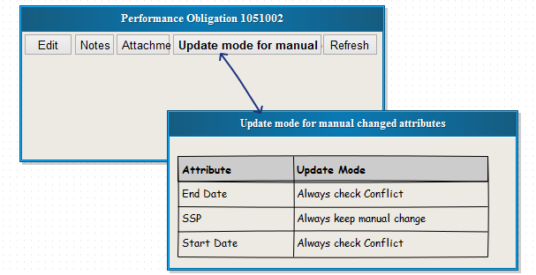

The user can also set the update mode in the conflict worklist directly.

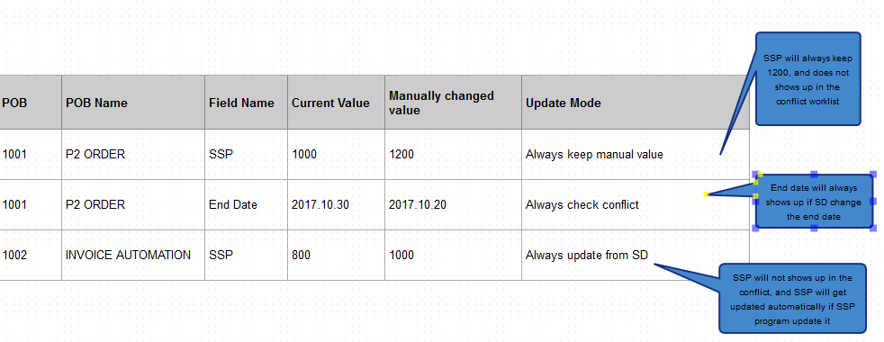

## REQ-008: It shall be possible to set default value for POB update mode via customizing

The end user shall have the possibility to set the default update mode for POB update mode in customizing Revenue Accounting -> Revenue Accounting Contracts -> Configure Automatic Overriding for Conflict Resolution (Customizing table FARR_C_CONFLI_EX).

In the customizing, the attributes of POB can be configured to get a default value of the update mode:

* Always update value from operation document
* Always keep manual changed value

If the attribute of POB is not configured in this customizing, it will by default get an update mode of ‘Always check conflict’.

## REQ-009: It shall be possible to review Revenue Contract with Conflict in the worklist “Contracts with Conflict

When conflict happens on Revenue Contract, it shall be put into a worklist: “Contracts with Conflicts”.

When the contract is opened from the Worklist “Contracts with Conflicts”, it shall be able to display different conflicts in separate tab

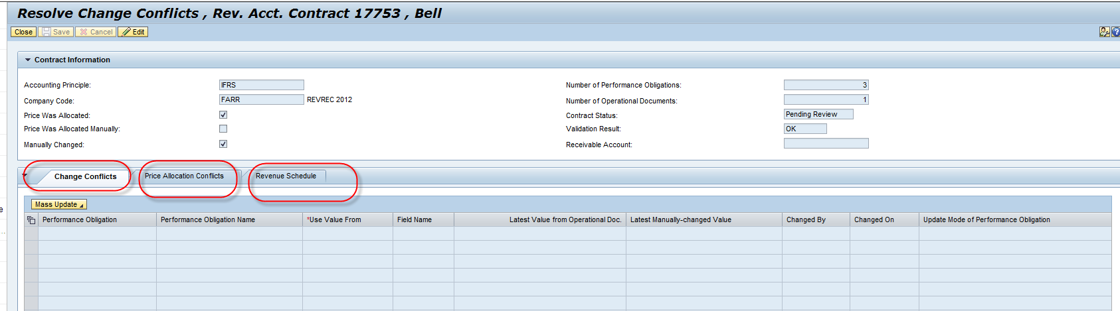

* **Tab: Attributes conflict**

Within this tab, it shall display all conflicts of POB attributes

In edit mode, the user can the end user shall be able to decide whether to take the latest value from operation document or keep the last changed manual value.

. The end user can also decide the update mode when there is a conflict on the screen.

* **Tab “Price allocation Conflict”:**

When conflict on price allocation happens, the tab “price allocation’ will display the current system allocation result, and the allocation result of last manual change.

In edit mode, the end user shall be able to do a manual price allocation in the UI.

* **Tab “Revenue Schedule Conflict”:**

When conflict on Revenue Schedule happens, the tab ‘Revenue Schedule Conflict’ shall list all POBs that have conflict on spreading. The list will display the old allocated amount and new allocated amount.

The end user shall be able to click the pushbutton Revenue Schedule and adjust the Spreading again.

If the user want to adjust spreading, he/she must exit ‘edit’ mode.

**Edit/Save the conflict.**

* As described above, Price allocation conflict and attribute conflict shall be resolved and edited in conflict worklist.
* When ‘Save’ button is clicked, the Revenue Accounting Engine will check if the input in tab ‘Attributes Conflict’ and ‘Price allocation conflict’ is valid.
* After ‘Save’, Revenue Accounting Engine shall detect if there are conflict on spreading because the allocated amount on POB might be changed. If yes, the contract is still in the status of conflict. If not, the contract is removed from conflict worklist.

## REQ-010: It shall be possible to correct POB attributes conflicts via worklist “Contract with Conflicts” or in contract management UI.

poi

POB with attributes is updated

Determine source of updated

Update from Conflict Worklist

Update from Contract Management

Update from RAI

Attributes has the same value

Update mode <> always check conflict

For each attribute with conflicts

Remove conflict on this attribute

Remove attribute conflict on this POB

End user confirm to POB attributes conflict is resolved

No attribute conflict

## REQ-011: It shall be possible to correct POB allocation conflicts via “Contract with Conflicts” or in screen ‘Manual price allocation”

Contract with price allocation is updated

Determine source of updated

Update from Conflict Worklist

Update from manual price allocation

Update from Contract Management

Remove price allocation conflict

Update from RAI

Contract stays in price allocation conflict

## REQ-012: It shall be possible to correct POB spreading conflicts via ‘Change Spreading’ or by changing allocated amount

POB with spreading conflict is updated

Determine source of updated

Update from Revenue Schedule

Update from RAI

Update from manual price allocation

Update from Contract Management

New allocated amount = total manual spreading amount

New total manual spreading = total allocated amount

Save spreading

Remove spreading conflict

## REQ-013: RAR shall block revenue posting of any contracts with conflicts.

## REQ-014: RAR shall remove revenue posting block if the revenue contract with conflict does not have any conflict any longer